**New SSH Connection Method through CyberArk**

Following list of ip’s are enabled for CyberArk access

|  |  |  |
| --- | --- | --- |
| Sl.No | IP Address | Instance Name |
| 1 | 10.176.48.203 | eis-nonprod-kdcmaster-ec2 |
| 2 | 10.176.50.219 | eis-nonprod-kafka-node1-ec2 |
| 3 | 10.176.50.150 | eis-nonprod-elasticsearch-node2-ec2 |
| 4 | 10.176.48.47 | eis-nonprod-kdcslave-ec2 |
| 5 | 10.176.48.144 | eis-nonprod-calculator-ec2 |
| 6 | 10.176.52.78 | eis-nonprod-kafka-node2-ec2 |
| 7 | 10.176.53.161 | eis-nonprod-kafka-node3-ec2 |
| 8 | 10.176.51.12 | eis-nonprod-elasticsearch-node1-ec2 |
| 9 | 10.176.51.52 | eis-nonprod-zookeeper-node1-ec2 |
| 10 | 10.176.53.207 | eis-nonprod-zookeeper-node3-ec2 |
| 11 | 10.176.48.167 | eis-nonprod-workbranchUI-ec2 |
| 12 | 10.176.53.162 | eis-nonprod-elasticsearch-node3-ec2 |
| 13 | 10.176.48.172 | eis-nonprod-oppcalculator-ec2 |
| 14 | 10.176.51.29 | eis-nonprod-logstash-ec2 |
| 15 | 10.176.51.231 | eis-nonprod-zookeeper-node2-ec2 |

**Connection String for Putty**

<your ACF2ID>@<CyberArk ID>@<Destination Server>@ psmpaws.nylcloudlabs.com

Example

T15kq9r@ec2-user@10.176.50.219@psmpaws.nylcloudlabs.com

Screen Shots

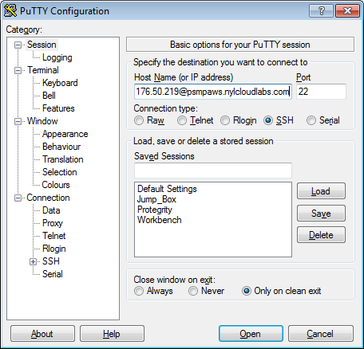

Enter Your SSO Model env Password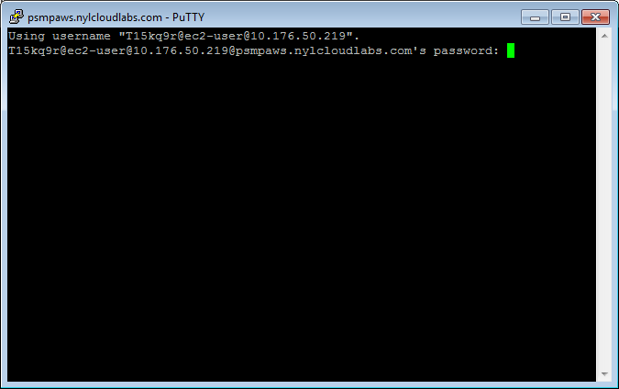

Enter Reason for Access

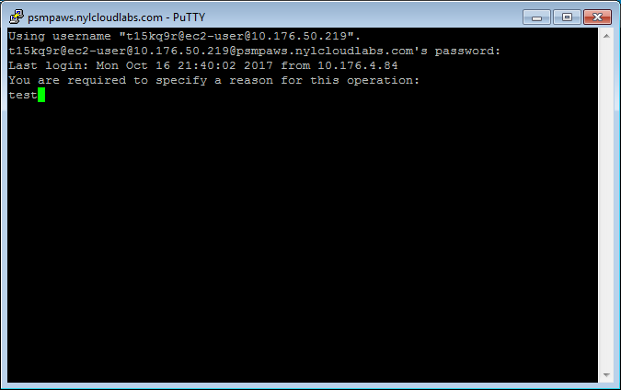

You are logged in

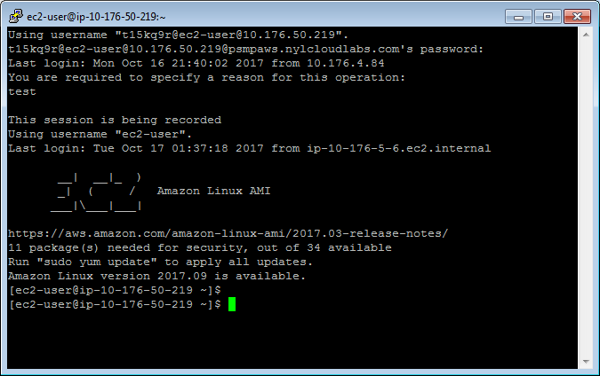

**Copying Files to Unix Servers**

You can now copy files to Unix servers without using Win-SCP on CyberArk. For this you will need the PSCP utility which allow you to run SCP from your local machine.

Download Link for PSCP

<https://the.earth.li/~sgtatham/putty/latest/x86/pscp.exe>

This is the command Syntax to copy files to the server

Pscp.exe -scp <Local File Name> <Your ACF2ID>@<CyberArk ID>@<Remote Server Name>@ psmpaws.nylcloudlabs.com:/<Remote Directory>

Example

**pscp -scp my.ini t01b3u7@ec2-user@10.176.51.148@psmpaws.nylcloudlabs.com:/tmp**

**Screen Shots**

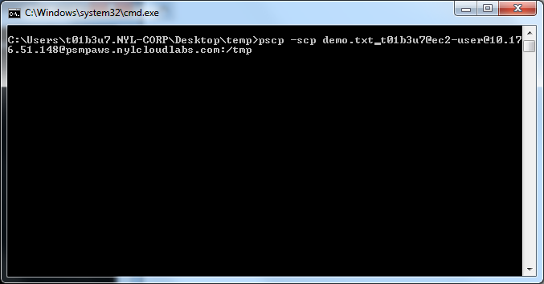

**Enter Your Windows Password**

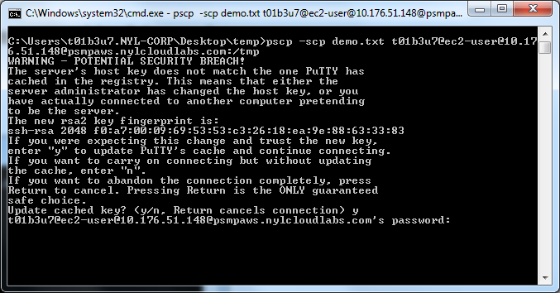

**File is copied to the remote server**